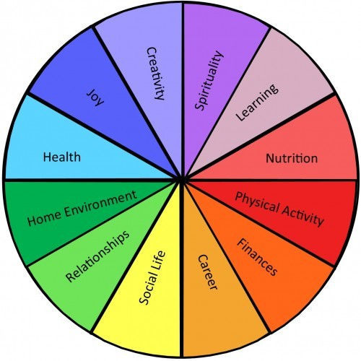
My vision for the future is painted with the vibrant colours of ambition and the soft hues of personal aspirations by using SMART (Specific, Measurable, Attainable, Relevant, and Timely.

I think a lot of times we hide our goals because we think, what if I fail? Well, what if you don’t? Accountability and visibility might be just what you need to succeed. Listen, I’m not saying you must post it on social media, but I am saying life-change rarely happens alone on an island and here are some examples of my life goals by using SMART (Specific, Measurable, Attainable, Relevant, and Timely.

Health: Health is often the first category in a list of life goals. If people don't take responsibility for their health, other goals may fall by the wayside. I mainly focus on healthy food for my immunity level. I will open a fresh juice and fresh food centre, after getting job in my IT field after 2 years of IT program.
Career: Career goals can define a person's career path. For example, an entry-level engineering graduate might want to secure a management position. my professional goals in life define your career path, and i can try to ensure your goals are compatible with the company's values after 2 years of my IT program.
Community: Helping the community can demonstrate commitment to the people around you and how important progress and improvement are. This can be done by volunteering with a community organization or starting one. I will be work with the aged care as volunteer. I will plan to take part as volunteers after 5 years of financial stability.
Family: Family is an entire category of goals. Intentionality needs to be put into relationships with family members to keep them healthy and positive. I always focused and I will focus on what my family needs. I will plan to go for long trip after 2 years with family.
Finances: A person's financial situation is closely linked to their need for safety, which can affect other areas of life. After finishing my goal to work with good and reputed company for my financial management. I will get good job after finishing my 2 years of masters program.
Spiritual growth: focus my work 100% on my purpose- people development, turn every ordinary moment to extraordinary through mindful presence. Clarify my purpose and create the business plan to focus on my purpose.
Physical Growth: 3-4 exercise a week. Balance my food and reduce sugar and lose 7kg and maintain this as new base line. I went to a nutritionist, managed to hit the gym 4x a week and lost the desired 7K. I’ve started on supplement program to re-balance my sugar and use an APP to be more mindful of what I eat.
Relationship growth: spend quality time with parents, kids, husband, and friends. Emotional Growth- bring daily gratitude and meditation practice into my life. I decided to pamper my parents with a trip to Australia and join my husband (as trailing spouse) for the first time for his two weeks business travel after 2 years.
And finally Inspire growth in others: Lead women empowerment retreats. I will give my first lectures after finishing my IT (2 years), and the talk I will be at the amazing EVE women empowerment events.
In conclusion, Smart model give a very specific guideline and time frame about future goals.

